|  |  |
| --- | --- |
| **Assignment Case** |  |
| COMP6153  Operating System |
| **Computer Science** | **O183-COMP6153-FN03-01** |
| ***Valid on*** *Odd Semester Year 2017/2018* | **Revision 00** |

## Soal

*Case*

1. From **home directory**, write a **command line** to create directory based on the hierarchy below in a single execution!

<Home directory>

`-- Coffee Shop

|-- Menu

| |-- Drinks

| | |-- Coffee

| | |-- Tea

| |-- Desserts

|-- Contact Us

1. From **Coffee Shop folder**, write a command line to create a new file named **Contact.txt** inside the **Contact Us** folder, then **set permission** so **owner** able to **read**, **write** and **execute** **file**, while **others** only able to **read** and **execute** the file.
2. From **Coffee Shop folder,** write a command line to **search files** with the following criteria:

* **Inside Coffee Shop folder**
* **Size below 1 MB**
* **The types are .txt**

1. Write a command line to display **all processes for all users**, while **sort the processes by process ID in ascending**.
2. Java Programming:

**Fnbucks Coffee Shop**

**Fnbucks Coffee Shop** is a newly established coffee shop in Indonesia. As a programmer, you are asked to create a program to handle customer orders.

Here are the detail requirements of the application:

* The application use **Object Oriented Programming** concept and **Inheritance**
* Create methods to calculate the **Base Price**, **Size** **Price** and **Total Price**
* When the **program starts**, ask the user to **input menu** **they want to** **order**. Validate the inputted menu must be between “C**offee**” and “**Cheese Cake**”(**case sensitive**).

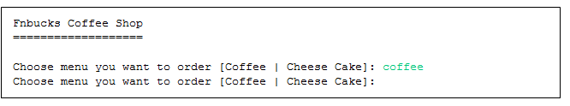**Figure 1. Screenshot of Adding Order**

* Set the Base Price for each menu with the following formula:

Base Price = rating * 10000

* If user input **Coffee** on menu, then:
* Ask the user to input **Name**. Validate the **Name** with the following format:
* **Must be between 5 and 20 characters**
* **Must be alphabet only**
* Ask the user to input **Size**. Validate the **Size** must be between “**Small”**, “**Medium”**, and “**Large”** (**case** **sensitive**).
* Ask the user to input **Type**. Validate the **Type** must be between “**Cold”** and “**Hot”** (**case** **sensitive**).
* Ask the user to input **Rating**. Validate the **Rating** must be **between** **1 and 4**.
* Ask the user to input **Quantity**. Validate the **Quantity** **must be at least 1**.

**Figure 2. Screenshot of input Coffee order**

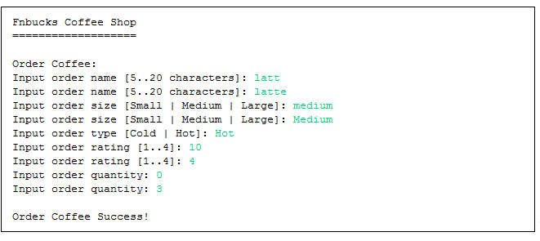

* Determine the Size Number based on the following rules:

|  |  |
| --- | --- |
| **Size** | **Size Number** |
| Small | 1 |
| Medium | 2 |
| Large | 3 |

* Determine the **Size Price** with the following formula:

**Size Price** = Size Number * 5000

* Calculate the **Total Price** with the following formula:

**TotalPrice** = ( Base Price + Size Price ) * Quantity

* Display **Name**, **Size**, **Type**, **Quantity**, **Rating** and **Total** **Price** of the inputted order

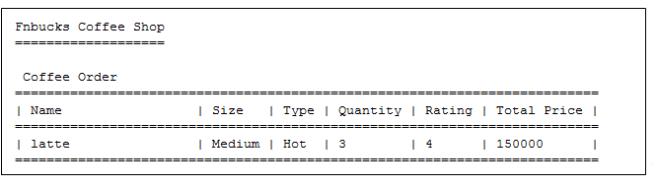**Figure 3. Screenshot of View Coffee Order**

* If user input **Cheese Cake** on menu, then:
* Ask the user to input **Name**. Validate the **Name** with the following format:
* **Must be between 5 and 20 characters**
* **Must be alphabet only**
* Ask the user to input **Rating**. Validate the **Rating** must be **between** **1 and 4**.
* Ask the user to input **Quantity**. Validate the **Quantity** must be **more** **than** **0**.

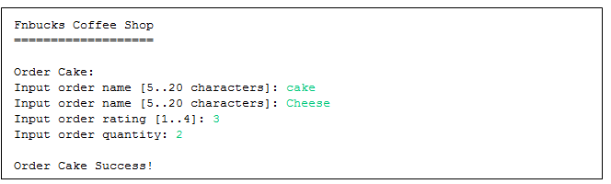**Figure 4. Screenshot of Add Order**

* Then, calculate the **Total Price** with the following formula:

**Total Price** = Base Price * Quantity

* Display **Name**, **Quantity**, **Rating** and **Total** **Price** of the inputted order

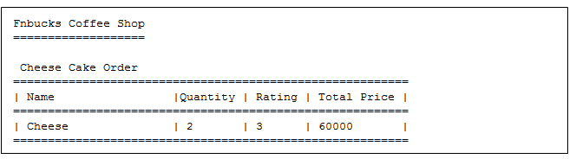**Figure 5. Screenshot of View Cheese Cake Order**

**Please run the EXE file to see the sample program.**